**SEQUENTIAL DIAGRAM**

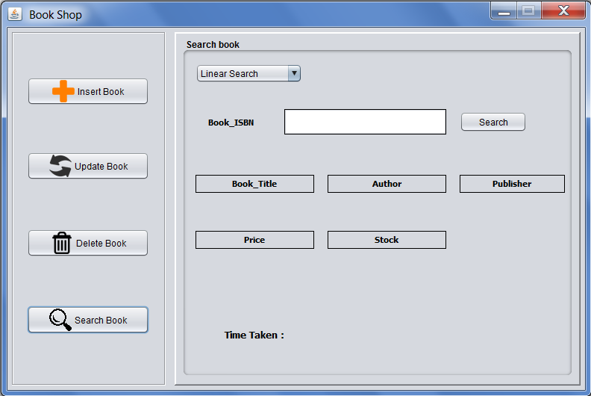

Search Window

In above Interface, the user will choose a method among: ***Linear Search***, ***Binary Search*** and ***Compare Complexity.***

If user selects ***Linear Search*** or ***Binary Search*** , after inputting ***ISBN*** of the book to be searched and pressing **SEARCH** button, if book found then :

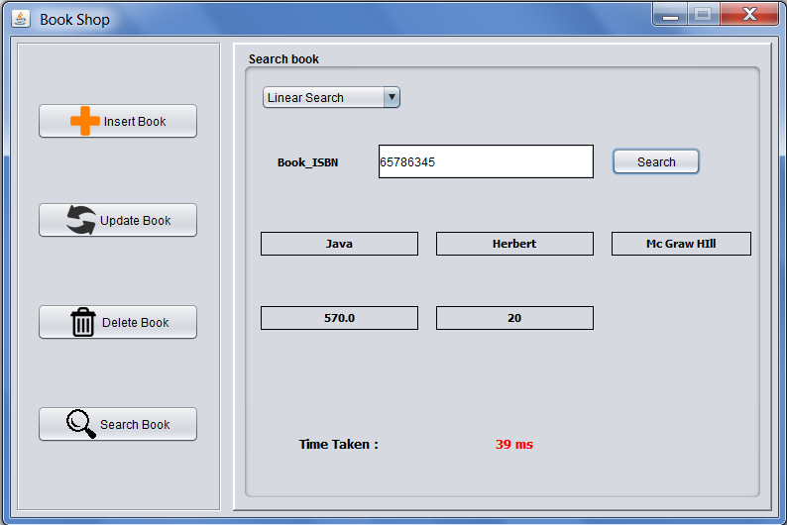

If book is not found then fields will show **N/F** that meant ‘Not-Found’:

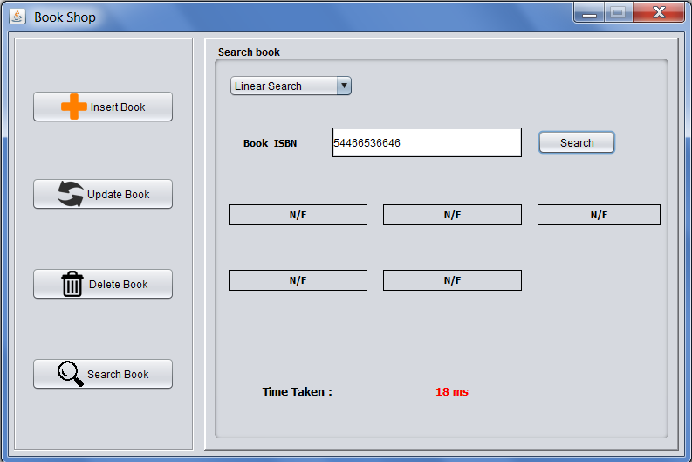  
If user selects ***Compare Complexity,*** then a new Interface will appear as:

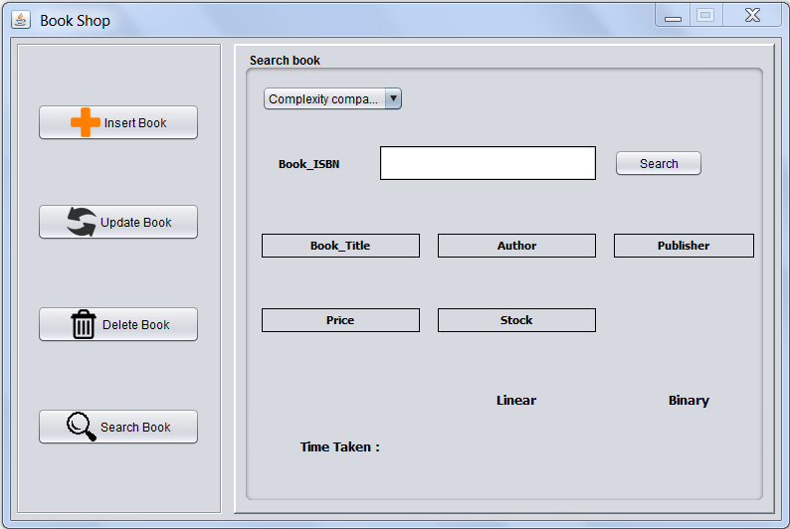

And when user will input **ISBN** of book to be searched and press **SEARCH** button and book is found then:

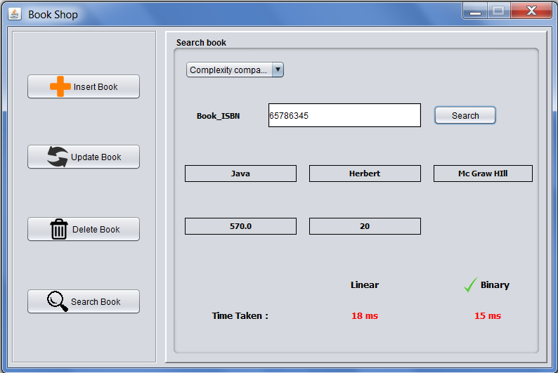

If Book is not found then N/F will be encountered:

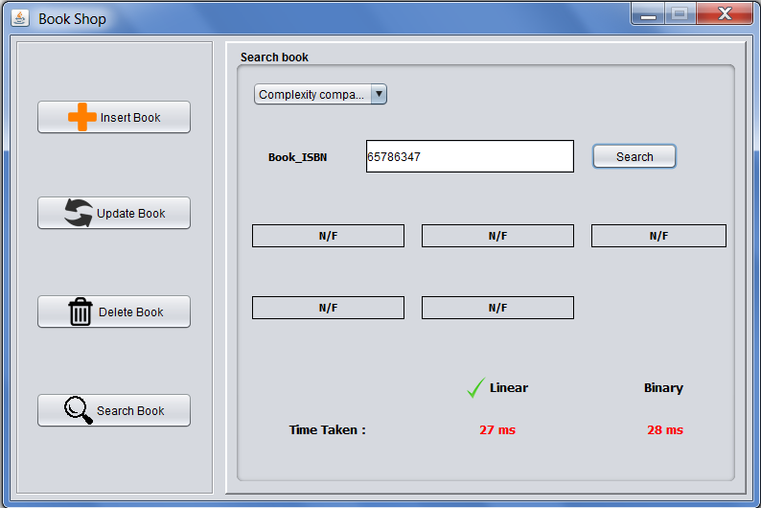

If any invalid or null ISBN is entered then following error will be displayed:

